San Benito - Summary MPA Combined Workgroups
Meeting Details:
Date: September 24, 2025
Time: 1:30 PM
Location: via Zoom

Summary:
On Wednesday, September 24 at 1:30 PM, the San Benito County Master Plan for Aging (MPA) workgroups held a combined meeting with all five goal areas together due to overlapping topics (especially transportation). Corey Shaffer opened the meeting, shared the playbook and agenda in the chat, and facilitated brief introductions with representatives from Seniors Council/ADRC, Alzheimer’s Association, Gavilan College, Behavioral Health, county planning, and other community partners. The group then moved through each MPA goal area in timed segments. For Housing for All Ages and Stages, participants highlighted recent progress including the county’s local tenant preference moving forward with added preference points for seniors and veterans, and recognition of the ADRC’s role in advocating for inclusion of individuals with disabilities as well. There was discussion about affordable housing development activity, the need to revive the “senior-friendly housing fact sheet/packet” effort using new resources shared through partner coalitions, and a reminder that older adults remain the fastest-growing unhoused population—framing urgency for continued advocacy. Questions about accessibility were addressed, noting ADA/accessibility requirements already exist within the building code for new construction. The group also discussed the idea of aligning outreach around May (Affordable Housing Month + Older Americans Month) and the broader need for designated “workgroup point people,” though leadership was also seen as naturally emerging through subject-matter experts.
For Health Reimagined, partners reported strong outcomes from Matter of Balance fall prevention classes, including a successful cohort at Vista Meadows with strong participation and community-building; additional classes were being explored with Casa Maria, potentially starting with a short fall-prevention talk. The group revisited interest in Tai Chi/chair yoga and acknowledged that cost and memberships (e.g., YMCA fees) can be a barrier for many older adults. The concept of Blue Zones came up as a possible strategy to support senior walkability and healthier community design, with a suggestion to connect with local health foundations and consider hosting a library screening/discussion to build awareness and engagement.
Under Inclusion & Equity, Not Isolation, the group shared progress on digital literacy and tech-help support through the library: monthly drop-in sessions were planned (initially September through December), with a focus on simple phone/tablet help and recruiting volunteers to assist. Partners explored expanding the effort to San Juan Bautista and possibly coordinating across libraries (including checking in again with Aromas and Gilroy resources). There was also discussion about piggybacking with related efforts (including media/information literacy work) and distributing printed volunteer flyers broadly across the county (including sites like the Esperanza Center and community events). A key emerging idea was creating a senior scholarship fund to offset costs that prevent participation in health, education, and enrichment opportunities—recognizing that even discounted rates can remain out of reach for many.
For Caregiving That Works, the group reviewed progress on the Gavilan College caregiving training program and acknowledged the first attempt was “rushed” and did not enroll enough students to run. Barriers discussed included the $1,200 cost and the length/format (e.g., 11 Saturdays), with alternative ideas offered such as shorter “one-shot” caregiver workshops, though partners raised concerns about duplicating existing training already offered by Del Mar/HPC and other organizations. Gavilan shared that new courses often take time to build enrollment, and noted strong interest (including requests for a Spanish offering). Practical solutions discussed included promoting payment plans, exploring eligibility for county assistance programs, and seeking scholarships/grants to buy down tuition. Possible funders and partners mentioned included health foundations, Hazel Hawkins Hospital Foundation (with scholarship cycles), workforce development contacts, and local corporate donors (e.g., major employers), with emphasis that successful fundraising requires relationships, a clear ask, outcomes/data, and appropriate recognition. A resource fair/job fair component at the end of the training was also discussed as a way to increase value and attract partners and participants.
Finally, for Affording Aging, Britt provided an update on the financial guide: progress has been slowed by the need for a knowledgeable reviewer to “vet” the content (with strong disclaimers already included), and by funding constraints for printing/distribution. Options discussed included identifying a trusted financial professional willing to review the guide, exploring printing support, and using QR-code cards or flyers as a practical fallback if printing funds aren’t available. The meeting closed with encouragement to continue building interest, offer interactive presentations of the playbook to new groups, and maintain momentum through shared engagement. The team also discussed timing for future meetings (considering holiday schedules) and an interest in continuing the combined-workgroup format since it worked well.
You can review the notes from the Breakout Groups, which will guide our work on county-wide solutions, by clicking on the link below. This page also includes video recordings of the group meetings and outlines the goals from the Master Plan for Aging Solutions Summit https://seniorscouncil.org/solutions-summit-2024/

Next Meeting:
- Date: 1.28.26
- Time: 1:30 PM
- Location: via Zoom

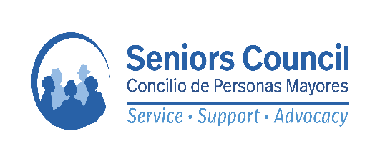
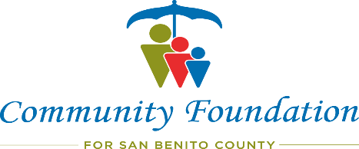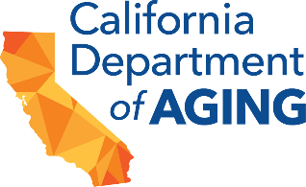

Seniors Council and the Community Foundation for San Benito County are partners in local aging initiatives, including San Benito Connect – Neighbor to Neighbor Volunteer Network and the State of California’s Local Master Plan for Aging planning and development initiative, working together to address local community aging and disability needs.
Funding for this work has been provided by the California Department of Aging, the State of California, Seniors Council of Santa Cruz & San Benito Counties, and the Community Foundation for San Benito County.

